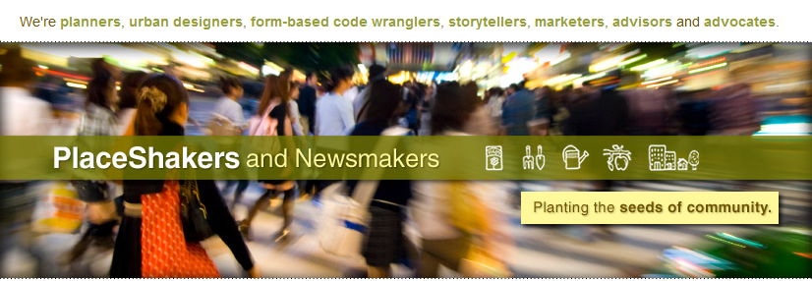
November 18, 2013 | 7:30 pm

Richard Florida on Technology, Talent, and Tolerance
Last Friday, I attended an inspiring Richard Florida luncheon put on by the Winnipeg Chamber, and can’t resist sharing the high points with you.
Technology, talent and tolerance are essential to fostering creative cultures. When we talk about the creative class, we aren’t talking about some rarified, exclusive group of people. Every human is creative. Creative cultures stoke that fire.
The economic crisis that we’re still living through is not simply a business cycle shift, but rather the biggest economic and social shift society has ever experienced.
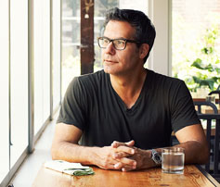
For all human history, we’ve created wealth in a simple way: we’ve used physical skills to transform natural resources. The global economy was a physically powered, raw material system – until now.
Robert Sternberg first said if you come across a great leader or designer, you’ve really come across a creative person.
Karl Marx claimed that what makes us human is the fact that we share physical labour. But this misses the essence of our shared creativity.
The creative class numbers 35% of our workforce in the US and Canada, and generates over half of our Gross Domestic Product. And it’s rapidly growing. In some neighbourhoods, the creative class makes up 90% of the workforce. These are invariably walkable neighbourhoods.
What we are living thru is the failure of the suburban growth model … the primary reason for the global financial crisis.
The segments of our economy that drive the most wealth are business and management, science and technology, banking and finance, and arts and culture.
Is your city carefully nurturing technology, talent, and tolerance? Are these business segments thriving in your community? Openness is the key to Canada’s success. Tolerance is the canary in the coalmine.
Reindustrialization (instead of Deindustrialization) is a marker of creative places. It relies not only on great CEOs and MBAs, but also on the intelligence of workers being enabled and celebrated. And the more creative the workforce – in the factory setting as well as the design studio – the more likely they are to demand walkable, round-the-clock places to live and work.
It’s not the machines that make a factory great – it’s the talent and creativity of the workers. Society has become divided between creative and non-creative classes. One group is getting ahead, and one is not. We made industrial jobs good jobs on purpose after World War II. Our challenge is to make everyone’s job a good job today. How do we move from a creative class into a creative culture?
Creativity isn’t a theory about hipsters and the latte set. The key driver of a resilient economy is the same thing that binds us as humans – our shared creativity.
About 100,000 people in Winnipeg belong to creative class. Winnipeg has one of the highest concentrations of musicians on the planet, and it shows on the streets. 250,000 are in the service economy, some with precarious employment. Enabling that service economy to get more creative drives wealth, both at the household level and at the City level.
Tony Hsieh, the CEO of Zappos, writes in his book, Delivering Happiness, about why moving his office from the ‘burbs to downtown Vegas was an act of placemaking that enabled the creativity of his workforce in a heavily service-oriented city. The insight of Zappos was not to build another corporate campus, but to rebuild a city. Silicon Valley and Nerdistan is the old way.
Zappos isn’t the only company moving back to downtown. Google in NYC, Twitter in San Francisco, and there are rumors of the GooglePlex moving to a more urban setting. Our cities are our creative furnaces, and the most nimble firms are making use of the fire.
The creative revolution is complete. The urban revolution — the way of life revolution — is just beginning.
Jane Jacobs said that companies make things more efficient and productive, but the source of innovation is our cities. City innovation does not come from sprawled out burbs or towers, but from interaction on the street. Jacobs felt that new ideas require old buildings and innovation requires mixing and mingling. Reuse, repurposing and redevelopment of historic building stock are essential to competing with global cities.
Quality of place – unique territorial offerings – is today’s competitive advantage for cities. Quality of place requires a balance of natural and built environments, a mix of people and a mix of activities. Synthesis of the built and natural environment is where the magic happens, like the ravine system in Toronto. Technology, talent, tolerance, and territorial offerings make places sing.
Great cities are built on the hierarchy of fulfilling human needs:
1. Safety and security
2. Economic opportunity
3. The ability to be engaged with equality
4. Placemaking
A big “thank you” to Richard for coming to Winnipeg to share the latest iteration of his ideas. This quick summary pales in comparison to his charismatic delivery, so check out Creative Class Group to find a podium near you.
Friday evening, as I was dropping our son off at a birthday party, another mom who had listened to Richard’s lecture asked me what I thought. Having heard him a few times before and staying so busy implementing many of his ideas that we’ve hardly had time to blog lately, thanks to Hillsborough County, FL – Southwestern NC – Dona Ana County, NM – Rosser, MB – and Decatur, GA – Marquette, MI – Phoenix, AZ, to name a few. Clearly my review is from the trenches so I am invigorated by his message.
My friend’s view, however, is from a legal perspective and she was left wanting to hear how to implement these creative culture ideas with the sorts of connected, complete, convivial places that spark creativity and nurture its ongoing viability. For any others with her same question, I recommend our frequent blogs on upgrading land-use laws to enable walkable places along with the Codes Study, which tracks the leaders in this field. If you’re interested in reindustrialization, check out these blogs by Scott Bernstein and me.
Creative Class Group projects often deal with both the policy and final projects that bookend land use reform. And as always, I’m interested in hearing your perspectives in the comments below.
–Hazel Borys
If PlaceShakers is our soapbox, our Facebook page is where we step down, grab a drink and enjoy a little conversation. Looking for a heads-up on the latest community-building news and perspective from around the web? Click through and “Like” us and we’ll keep you in the loop.

